

**Cloud Computing Architecture Lab**

**Name:** Pratham Kandari

**Sap Id:** 500097663

**Batch:** 7

**Experiment -12**

# AWS Web Application Firewall (WAF)

**Ubuntu on Vmware workstation**

Step 1) Open Vmware Workstation player and click on create a new Vm.

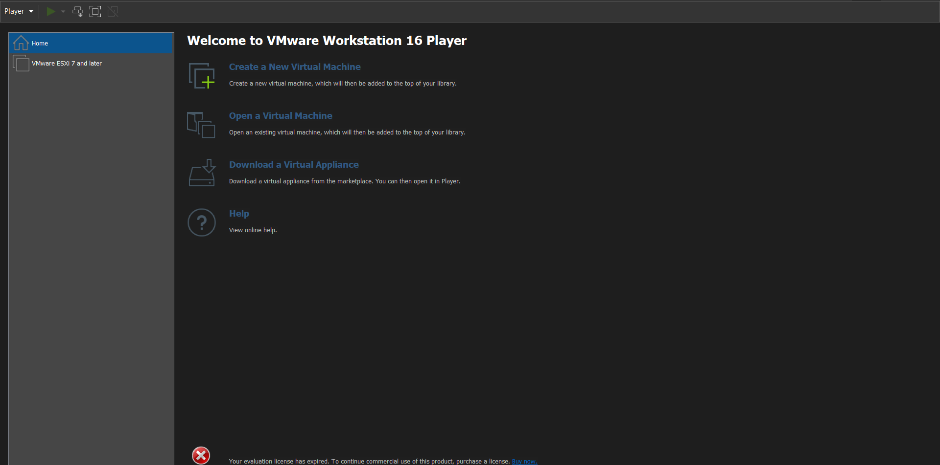

Step 2) Select the iso file you want to install.

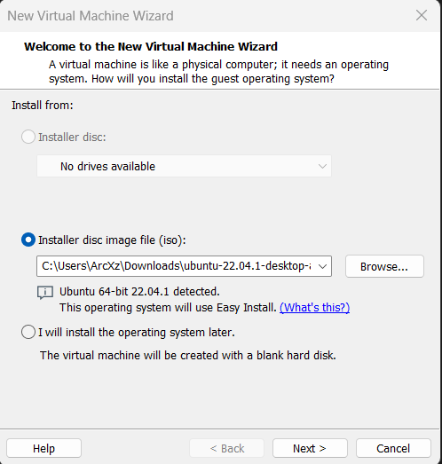

Step 3) Give your username and password.

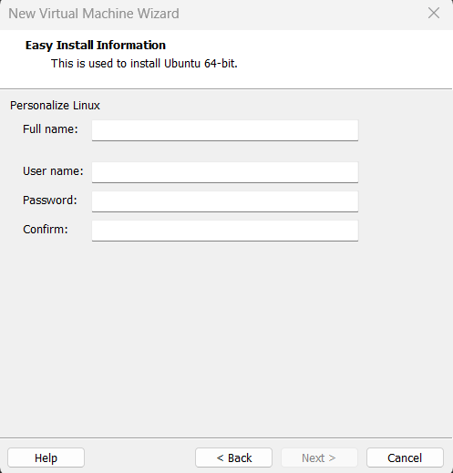

Step 4) Give your VM a name.

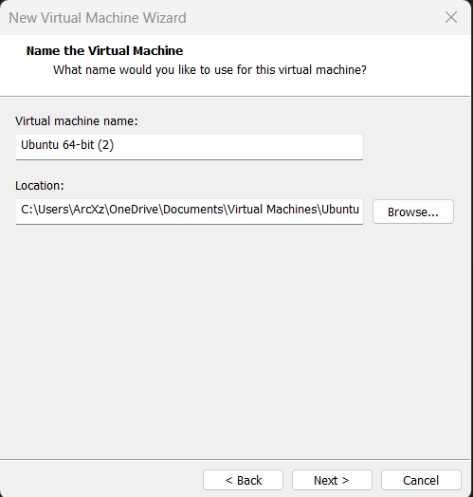

Step 5) Specify Disk Capacity.

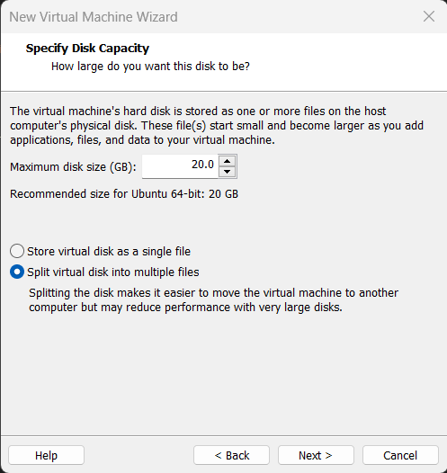

Step 6) Review and finish.

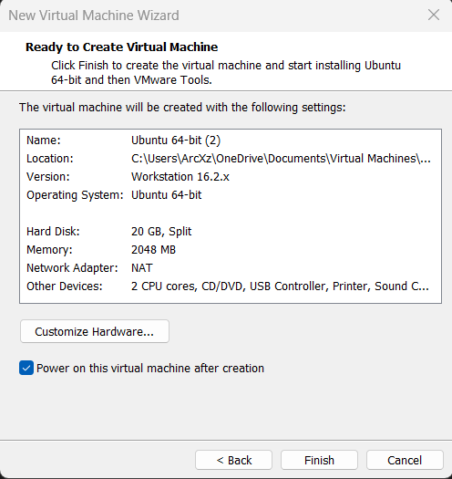

Step 7) After your VM is powered on and install it.

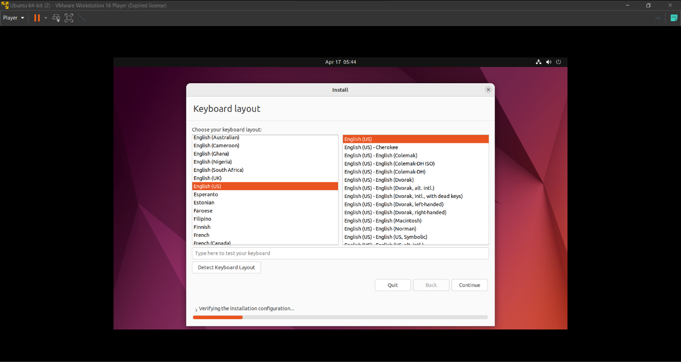

Step 8) After installing your ubuntu VM will be usable.